can pages (ADRs) be retrieved and placed as copies in s3 bucket as RAG for generative AI where each ADR is assessed whether it meets the minimum standards of an ADR template and whether there are any references of content to other ADRs

ChatGPT said:
ChatGPT
Yes, Confluence pages (ADRs) can be retrieved, validated against a template, and stored in an S3 bucket to serve as Retrieval-Augmented Generation (RAG) content for a generative AI system. Additionally, each ADR can be assessed for compliance with a minimum ADR template standard and cross-referenced for links to other ADRs.
Here’s how you can set this up step-by-step:

Step 1: Retrieve ADRs from Confluence
- Fetch ADR Pages:
  - Use the Confluence REST API to query and retrieve ADR pages.
  - For a space or specific parent page:
    - Use /space/<space-key>/content for all pages in a space.
    - Use /content/<parent-page-id>/child/page for child pages.
Example Python Script:
python
Copy code
import requests

# Confluence API credentials
base_url = "https://<your-domain>.atlassian.net/wiki/rest/api"
headers = {
"Authorization": "Basic <encoded_email_and_api_token>",
"Content-Type": "application/json"
}

# Function to fetch pages
def fetch_pages(space_key):
url = f"{base_url}/space/{space_key}/content"
response = requests.get(url, headers=headers)
return response.json()["results"] if response.status_code == 200 else []

adr_pages = fetch_pages("ADR_SPACE") # Replace with your space key
- Extract ADR Content:
  - For each page, retrieve its title, body.storage.value (HTML content), and metadata.
  - Example:
python
Copy code
def get_page_content(page_id):
url = f"{base_url}/content/{page_id}?expand=body.storage"
response = requests.get(url, headers=headers)
if response.status_code == 200:
page = response.json()
return {
"title": page["title"],
"content": page["body"]["storage"]["value"]
}
return None

Step 2: Validate ADR Against a Template
- Define the Minimum ADR Template: Example fields:
  - Title
  - Status
  - Context
  - Decision
  - Consequences
- Check Compliance:
  - Use an NLP library (e.g., spaCy or NLTK) to assess whether key sections are present.
  - Example:
python
Copy code
def validate_adr(adr_content):
required_sections = ["Context", "Decision", "Consequences"]
missing_sections = [
section for section in required_sections if section not in adr_content
]
return {
"is_valid": len(missing_sections) == 0,
"missing_sections": missing_sections
}

Step 3: Detect References to Other ADRs
- Search for Cross-References:
  - Use regex patterns to detect references (e.g., "ADR-001" or linked page titles).
  - Example:
python
Copy code
import re

def find_references(adr_content):
# Pattern for identifying references like ADR-001
pattern = r"ADR-\d+"
references = re.findall(pattern, adr_content)
return references
- Cross-Check References:
  - Query Confluence for each referenced ADR to ensure it exists.
  - Add validation for broken links.

Step 4: Store ADRs in S3 for RAG
- Save ADRs as JSON:
  - Convert each ADR into a structured JSON format:
json
Copy code
{
"title": "ADR Title",
"status": "Accepted",
"context": "Context content",
"decision": "Decision content",
"consequences": "Consequences content",
"references": ["ADR-001", "ADR-005"],
"is_valid": true,
"missing_sections": []
}
- Upload to S3:
  - Use the AWS SDK to upload processed ADRs to an S3 bucket:
python
Copy code
import boto3
import json

s3 = boto3.client('s3')

def upload_to_s3(bucket_name, file_name, data):
s3.put_object(Bucket=bucket_name, Key=file_name, Body=json.dumps(data))

for adr in adr_pages:
adr_content = get_page_content(adr["id"])
validated_adr = validate_adr(adr_content["content"])
references = find_references(adr_content["content"])

adr_data = {
"title": adr_content["title"],
"content": adr_content["content"],
"is_valid": validated_adr["is_valid"],
"missing_sections": validated_adr["missing_sections"],
"references": references
}

file_name = f"adrs/{adr_content['title'].replace(' ', '_')}.json"
upload_to_s3("my-rag-bucket", file_name, adr_data)

Step 5: Build the RAG Workflow
- Index ADRs:
  - Use Amazon OpenSearch Service to index the ADRs for semantic search.
  - Include fields like title, content, references, and validation status.
- Fine-Tune a Generative Model:
  - Use Amazon SageMaker to fine-tune a pre-trained GPT or similar model on ADR content to:
    - Generate new ADRs.
    - Suggest improvements to existing ADRs.
    - Identify and link related ADRs.
- Search and Retrieve ADRs:
  - Retrieve relevant ADRs using OpenSearch and provide them as context for the generative model.

Step 6: Automate the Pipeline
- Trigger for New ADRs:
  - Use Confluence Webhooks or a scheduled Lambda function to fetch new ADRs periodically.
- Validation Workflow:
  - Validate each ADR and update its metadata in S3 and OpenSearch.
- Notification for Issues:
  - Use Amazon SNS to notify relevant teams if ADRs are non-compliant or have broken references.

Step 7: Deploy the System
- Frontend Interface:
  - Build a UI with React.js or Vue.js to display ADR validation statuses, linkages, and search capabilities.
- Backend APIs:
  - Use API Gateway and Lambda to serve validation results, retrieve ADRs, and allow uploads.

Would you like detailed help with any specific step, such as indexing ADRs in OpenSearch, fine-tuning a generative AI model, or building the validation pipeline?
4o

You said:
yes please why do I need indexing?

ChatGPT said:
ChatGPT
Indexing in this context is essential for enabling efficient search and retrieval of ADRs, especially when implementing a Retrieval-Augmented Generation (RAG) system for generative AI. Here's why indexing is important and how it benefits your system:

Why Do You Need Indexing?
- Efficient Search and Retrieval:
  - Indexing allows you to quickly find relevant ADRs from a large dataset based on:
    - Full-text search (e.g., searching within context, decision).
    - Semantic search (e.g., understanding user queries contextually).
    - Metadata search (e.g., filtering by status or missing_sections).
- Supports Retrieval-Augmented Generation (RAG):
  - In RAG, relevant documents are retrieved from a knowledge base to provide context for AI-generated responses.
  - For example:
    - A user submits a query like, "What decisions were made regarding logging?"
    - The system retrieves related ADRs before passing them to the generative AI.
- Facilitates Linking and References:
  - Indexing helps identify and link ADRs with similar context, decision, or explicit references (e.g., "ADR-001").
  - This ensures related decisions are accessible during analysis or generation.
- Improves Validation Workflows:
  - You can use indexed metadata to quickly identify ADRs missing required sections, non-compliant ones, or broken references.
- Scalability:
  - As the number of ADRs grows, indexing ensures that your system remains performant without scanning all records for every query.

How Indexing Works
Indexing involves organizing data into a structure optimized for querying. With tools like Amazon OpenSearch Service, your ADR data is indexed into fields (e.g., title, context, decision) that can be searched efficiently.

How to Implement Indexing for ADRs

Step 1: Choose an Indexing Tool
- Use Amazon OpenSearch Service (fully managed Elasticsearch-compatible service).
- Alternatives:
  - DynamoDB with PartiQL (for basic metadata search).
  - Amazon Kendra (for intelligent semantic search, but costlier).

Step 2: Define the ADR Index Schema
- Fields to Index:
  - title: For direct title searches.
  - context: For full-text or semantic search on the problem description.
  - decision: To retrieve specific decisions.
  - consequences: To find outcomes.
  - references: For linking ADRs.
  - is_valid: To filter compliant ADRs.
  - missing_sections: To identify issues.
- Example Schema for OpenSearch:
json
Copy code
{
"mappings": {
"properties": {
"title": { "type": "text" },
"context": { "type": "text" },
"decision": { "type": "text" },
"consequences": { "type": "text" },
"references": { "type": "keyword" },
"is_valid": { "type": "boolean" },
"missing_sections": { "type": "keyword" },
"created_date": { "type": "date" }
}
}
}

Step 3: Index ADRs in OpenSearch
- Create an OpenSearch Domain:
  - Go to the Amazon OpenSearch Service console.
  - Create a domain and note its endpoint.
- Create the ADR Index:
  - Use curl or a Python script to define the index schema:
bash
Copy code
curl -X PUT "https://<opensearch-endpoint>/adr-records" \
-H 'Content-Type: application/json' \
-d @schema.json
- Index ADR Documents:
  - For each processed ADR, add it to OpenSearch:
python
Copy code
import requests

opensearch_url = "https://<opensearch-endpoint>/adr-records/_doc"

def index_adr(adr):
response = requests.post(opensearch_url, json=adr, headers={
"Content-Type": "application/json"
})
if response.status_code == 201:
print(f"Indexed ADR: {adr['title']}")
else:
print(f"Failed to index: {response.text}")

# Example ADR document
adr = {
"title": "Logging Framework Decision",
"context": "We need a logging framework for microservices.",
"decision": "Use ELK Stack.",
"consequences": "Better observability, higher costs.",
"references": ["ADR-001"],
"is_valid": True,
"missing_sections": []
}
index_adr(adr)

Step 4: Query Indexed ADRs
- Basic Full-Text Search: Query for ADRs containing specific keywords:
python
Copy code
search_query = {
"query": {
"match": { "context": "logging" }
}
}

response = requests.get(
f"{opensearch_url}/_search",
json=search_query,
headers={"Content-Type": "application/json"}
)
print(response.json())
- Filter Non-Compliant ADRs: Use metadata like is_valid and missing_sections:
python
Copy code
search_query = {
"query": {
"bool": {
"filter": [{ "term": { "is_valid": False } }]
}
}
}
- Find Related ADRs: Search references or similar contexts:
python
Copy code
search_query = {
"query": {
"match": { "references": "ADR-001" }
}
}

Step 5: Integrate Indexing into RAG Workflow
- Fetch Relevant ADRs for Generative AI:
  - Query OpenSearch for ADRs matching the input query.
  - Example:
    - Query: "What decisions were made about logging?"
    - OpenSearch retrieves relevant ADRs.
    - Pass retrieved ADRs to a fine-tuned generative model as context.
- Store Retrieval Results in Context Window:
  - Limit the input to 2-3 most relevant ADRs to avoid token limit issues in large language models.
- Enable Feedback Loop:
  - Allow users to flag incorrect or missing links and update the indexed ADR metadata.

Benefits of Indexing
- Speed: Indexed ADRs can be retrieved in milliseconds, even for large datasets.
- Accuracy: Advanced filtering and semantic search improve result relevance.
- Integration: Seamlessly integrates with RAG workflows to enhance AI responses.
- Scalability: Handles growing ADR repositories without performance degradation.

Would you like more guidance on setting up the OpenSearch schema, optimizing queries, or integrating indexing with your AI model?
4o
page s3 bucket ? give me a high level diagram of the complete design

ChatGPT said:
ChatGPT
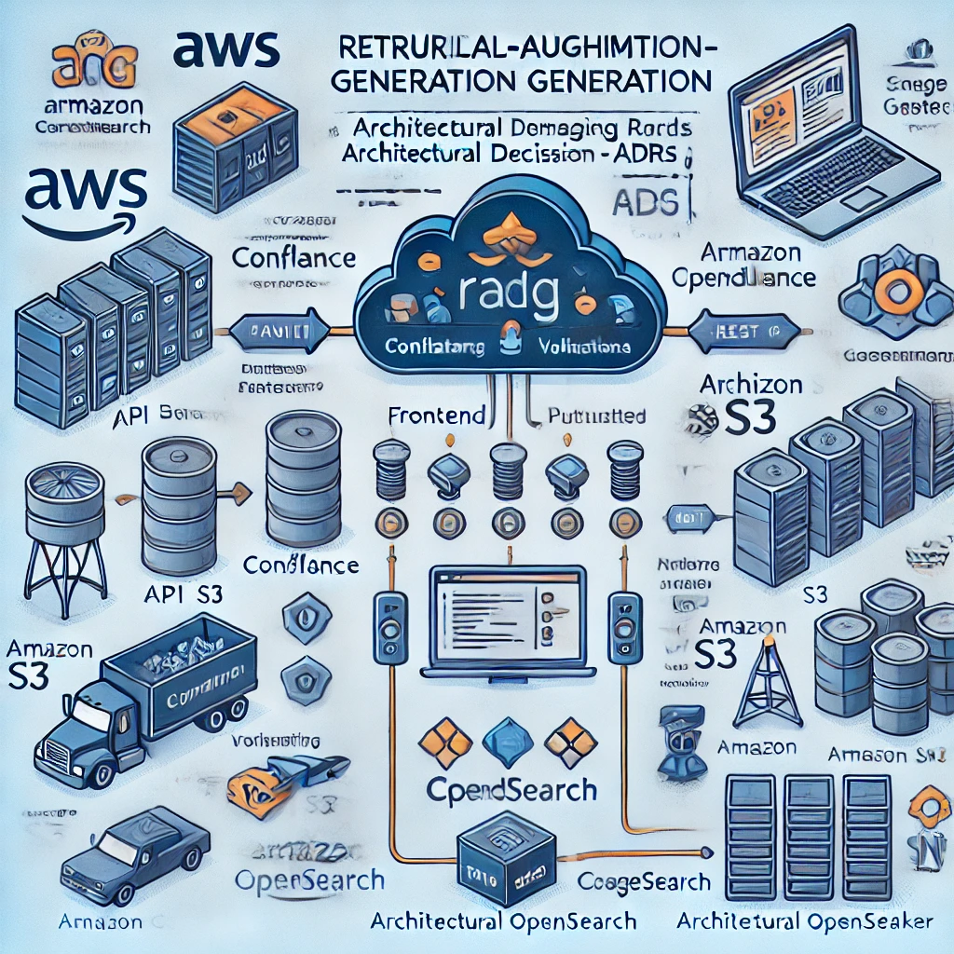
Here is the high-level architectural diagram for the system. It outlines the integration of AWS services and components required to process and manage ADRs with RAG-based generative AI. Let me know if you need further explanations or adjustments.

You said:
what else is required do I need to build a front-end using a static page s3 bucket ?

ChatGPT said:
ChatGPT
To build and deploy a front-end application using a static S3 bucket, you’ll need the following components and configurations. Here's an overview of what is required:

1. Building the Front-End Application
- Codebase Development:
  - Use a framework like React.js, Vue.js, or plain HTML/CSS/JavaScript.
  - Key features to implement:
    - Search Page: Interface to search for ADRs.
    - Submission Page: Form to submit new ADRs.
    - Details Page: Display retrieved ADR content and links.
- Build the Static Assets:
  - After development, run a build command to produce the deployable assets:
    - React: npm run build
    - Vue: npm run build
  - This generates a folder (e.g., build/ or dist/) containing HTML, CSS, and JavaScript files.

2. Setting Up an S3 Bucket
- Create an S3 Bucket:
  - Go to the S3 Console and create a bucket (e.g., adr-front-end).
  - Ensure the bucket name is globally unique.
- Enable Static Website Hosting:
  - Under the Properties tab of the bucket, enable Static Website Hosting.
  - Specify:
    - Index document: index.html
    - Error document: index.html (if using single-page apps like React/Vue).
- Set Permissions:
  - Configure a bucket policy to make the static site publicly accessible:
json
Copy code
{
"Version": "2012-10-17",
"Statement": [
{
"Sid": "PublicReadGetObject",
"Effect": "Allow",
"Principal": "*",
"Action": "s3:GetObject",
"Resource": "arn:aws:s3:::adr-front-end/*"
}
]
}
- Upload the Static Files:
  - Use the AWS CLI or S3 Console to upload the build folder contents:
bash
Copy code
aws s3 sync ./build s3://adr-front-end

3. Deploy CloudFront for Global Distribution
- Set Up a CloudFront Distribution:
  - Go to CloudFront Console and create a new distribution.
  - Origin Domain: Select the S3 bucket as the origin.
  - Enable caching and compression for improved performance.
- Configure Behaviors:
  - Specify a default behavior for requests.
  - Forward all requests to the S3 bucket.
- Set the Default Root Object:
  - Set index.html as the default root object for the distribution.
- Use a Custom Domain (Optional):
  - Add a custom domain (e.g., adr.example.com) via Route 53 and associate it with the CloudFront distribution.
  - Use an SSL certificate from AWS Certificate Manager (ACM) for HTTPS.

4. Backend API Integration
- API Gateway:
  - Deploy REST APIs via Amazon API Gateway to handle:
    - ADR search requests.
    - Submissions of new ADRs.
    - Retrieval of ADR details.
  - Example API routes:
    - /search
    - /submit-adr
    - /get-adr/{id}
- Connect API Gateway to Lambda Functions:
  - Use Lambda functions to interact with:
    - OpenSearch for querying ADRs.
    - Confluence for fetching new ADRs.
    - S3 for storing or retrieving ADR content.
- Secure the APIs:
  - Use Amazon Cognito or API Gateway Authorizers to secure endpoints.
- Frontend API Calls:
  - Use axios or fetch in the front-end app to communicate with the backend.
Example:
javascript
Copy code
const fetchADRs = async (query) => {
const response = await fetch("https://api.example.com/search", {
method: "POST",
headers: { "Content-Type": "application/json" },
body: JSON.stringify({ query })
});
const data = await response.json();
return data;
};

5. Monitoring and Logging
- Enable Logging:
  - Configure CloudFront Logs to monitor traffic.
  - Enable AWS CloudWatch Logs for API Gateway and Lambda.
- Track User Behavior (Optional):
  - Use tools like Google Analytics or AWS Pinpoint to monitor user interactions with the site.

6. Optional Enhancements
- Implement a CI/CD Pipeline:
  - Use AWS CodePipeline or GitHub Actions to automate deployment of the front-end:
    - On a code push, build the project and sync the build folder to the S3 bucket.
- Add Authentication (Optional):
  - Use Amazon Cognito for user sign-in, sign-up, and secure access to the APIs.
- Use S3 Transfer Acceleration (Optional):
  - Enable S3 Transfer Acceleration for faster uploads to the S3 bucket.

High-Level Workflow
- User Access:
  - The user accesses the static website via CloudFront.
- Frontend Interaction:
  - The frontend interacts with APIs for searching, submitting, and retrieving ADRs.
- Data Handling:
  - ADRs are stored in S3 and indexed in OpenSearch for efficient retrieval.
- AI Integration:
  - The system uses SageMaker for generative responses or validation tasks.

Would you like help with setting up any of these components, such as a detailed S3 bucket configuration or CloudFront setup?
4o

You said:
what else is required

ChatGPT said:
ChatGPT
To ensure your static front-end with S3 and AWS infrastructure meets all functional and non-functional requirements, here are additional considerations and components you may need:

1. Advanced Security
- Restrict S3 Bucket Access:
  - Use Origin Access Control (OAC) to restrict direct public access to the S3 bucket, allowing only requests through CloudFront.
- Secure API Access:
  - Implement Cognito User Pools or API Gateway Lambda Authorizers for user authentication and authorization.
  - Use IAM roles for Lambda to securely access S3, OpenSearch, or SageMaker resources.
- HTTPS Everywhere:
  - Ensure CloudFront is configured with an SSL/TLS certificate (via AWS Certificate Manager).
  - Redirect all HTTP traffic to HTTPS.
- Cross-Origin Resource Sharing (CORS):
  - Configure CORS rules on the S3 bucket to allow the frontend to interact with the backend APIs.

2. Performance Optimization
- CloudFront Cache Settings:
  - Cache static assets (HTML, CSS, JavaScript) with appropriate cache-control headers.
  - Enable GZIP or Brotli compression.
- Use Content Delivery Best Practices:
  - Split JavaScript files into smaller bundles to improve page load times.
  - Leverage lazy loading for images and scripts.
- Optimize Front-End Assets:
  - Use tools like Webpack or Vite to minify JavaScript and CSS files.
  - Optimize images using tools like imagemin.
- Enable S3 Transfer Acceleration (Optional):
  - Speed up file uploads or downloads to S3 from global locations.

3. Enhanced Frontend Features
- Interactive Dashboard:
  - Use charting libraries like Chart.js or D3.js to visualize ADR statistics.
  - Show trends like most referenced ADRs or recent decisions.
- Search Enhancements:
  - Provide advanced filtering (e.g., by status, date, decision type).
  - Add autocomplete functionality to search queries using OpenSearch suggestions.
- User Feedback:
  - Allow users to flag ADRs with issues or submit corrections.

4. Backend Enhancements
- Error Handling and Validation:
  - Ensure robust error handling for APIs:
    - Validate user inputs before storing ADRs.
    - Provide meaningful error messages for API failures.
- Rate Limiting:
  - Protect APIs using API Gateway throttling to prevent abuse.
- Webhook for Real-Time Updates:
  - Set up Confluence Webhooks to automatically update ADRs in S3 or OpenSearch when changes occur.
- Data Backup:
  - Enable S3 versioning for ADR storage to maintain a history of changes.

5. Observability
- Monitoring:
  - Use AWS CloudWatch to monitor:
    - S3 bucket access.
    - CloudFront requests.
    - API Gateway and Lambda performance.
  - Set up alarms for unusual traffic or API errors.
- Logging:
  - Enable CloudFront logging to track user interactions with the static site.
  - Use CloudWatch Logs Insights for analyzing logs from API Gateway and Lambda.
- Usage Metrics:
  - Implement Google Analytics or AWS Pinpoint for tracking user activity.

6. Scalable Deployment
- Continuous Integration/Continuous Deployment (CI/CD):
  - Automate front-end deployments using AWS CodePipeline or GitHub Actions:
    - Trigger builds on code pushes.
    - Deploy built assets to S3 and invalidate CloudFront cache.
- Infrastructure as Code (IaC):
  - Use AWS CloudFormation or Terraform to define and deploy your infrastructure, ensuring consistency and easy scalability.

7. Content Management
- Regular Updates:
  - Automate Confluence-to-S3 sync to ensure ADRs in S3 are up-to-date.
  - Run scheduled tasks with AWS EventBridge to revalidate ADRs or update OpenSearch indexes.
- ADR Validation Rules:
  - Expand validation criteria for ADR templates (e.g., checking specific keywords, decision quality).
  - Log validation results in DynamoDB for reporting.

8. Disaster Recovery
- Backup ADR Data:
  - Use S3 Cross-Region Replication to replicate ADR data to another region.
  - Backup OpenSearch snapshots regularly.
- High Availability:
  - Use multiple availability zones for backend services like OpenSearch and SageMaker endpoints.

9. Governance and Compliance
- Data Access Auditing:
  - Use AWS CloudTrail to log all API and S3 access events for auditing.
- Compliance:
  - Ensure compliance with regulations (e.g., GDPR) for storing ADRs and user data.

10. High-Level Checklist

Frontend
- Fully developed UI for search, submission, and retrieval.
- Deployed on S3 with CloudFront.
- Responsive design and optimized assets.

Backend
- APIs for ADR management.
- Integrated with Confluence, OpenSearch, and S3.
- Secure and scalable.

Infrastructure
- CloudFront caching and TLS configuration.
- S3 bucket policies and logging enabled.
- Automated deployment pipelines.

Enhancements
- Advanced search and filtering.
- Semantic search via OpenSearch or SageMaker.
- Monitoring and analytics.

Would you like detailed guidance on implementing any of these components, or should we dive into setting up a CI/CD pipeline or advanced search functionality?

